# Coffee Cart Automation Framework

This project is a Selenium + TestNG based automation framework designed to test the Coffee Cart web application. It uses the Page Object Model (POM), data-driven testing, and includes reusable utilities, listeners, and structured reporting.

## Features

- TestNG with suite-level control  
- Page Object Model (POM)  
- Data-driven tests via Excel  
- Centralized WebDriver management  
- ExtentReports / HTML test outputs  
- TestNG Listeners for custom logging  
- Maven for build and dependency management

## Architecture

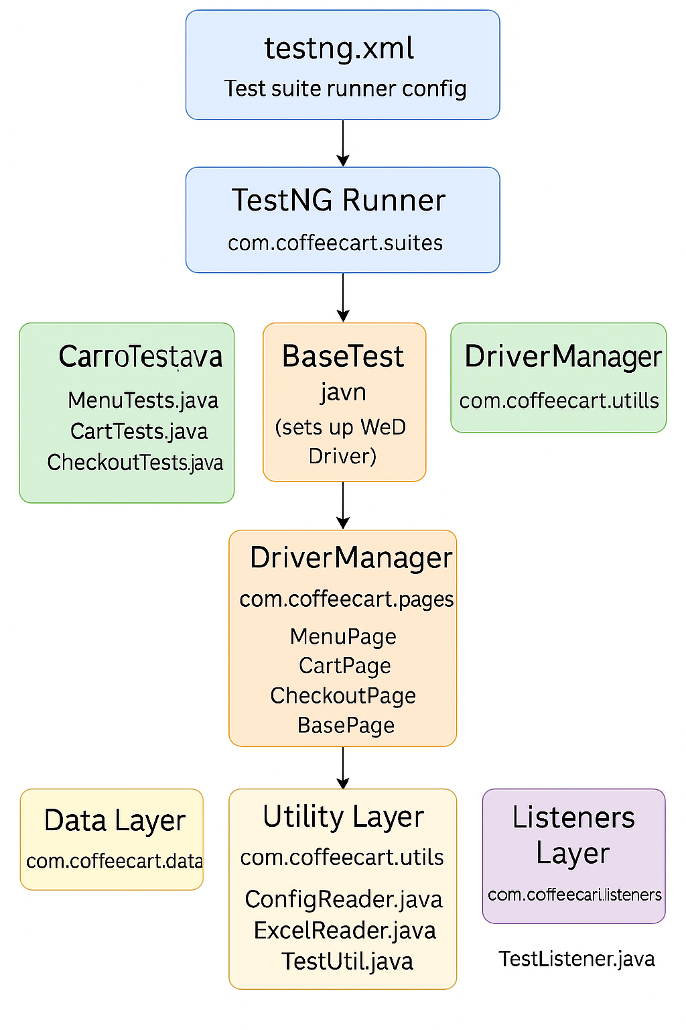

## Project Structure

Coffee Cart Automation Project/  
├── src/  
│ ├── main/java/com/coffeecart/  
│ │ ├── pages/ # Page Objects (MenuPage, CartPage, etc.)  
│ │ ├── managers/ # WebDriver manager  
│ │ └── utils/ # ExcelReader, ConfigReader, etc.  
│ └── test/java/com/coffeecart/  
│ ├── tests/ # Test classes (MenuTests, CartTests)  
│ ├── data/ # TestDataProvider  
│ ├── suites/ # TestNG runner  
│ └── listeners/ # TestListener  
├── resources/ # Excel/config files  
├── output/ # Test results/reports/screenshots  
├── pom.xml # Maven config  
└── testng.xml # TestNG suite

## How to Run

1. Clone the repository  
2. Import as Maven Project in IntelliJ or Eclipse  
3. Install dependencies:   
 mvn clean install  
4. Execute tests via:  
 mvn test  
 or directly from testng.xml

## Configuration

- Config file: resources/config.properties  
- Test data: resources/testdata.xlsx  
- Browser: Configurable via ConfigReader.java

## Reporting

Test results are generated under /output directory:  
- HTML reports  
- Screenshots on failure  
- Logs via listener hooks

## Contributors

- Created by: Akash Kuna R  
- Design & Implementation: Selenium + TestNG + Maven

## License

This project is for educational/testing purposes only. No license enforced.